2.2 System Frontend - SPECIMEN PORTAL

- Specimen Dashboard (index.php)

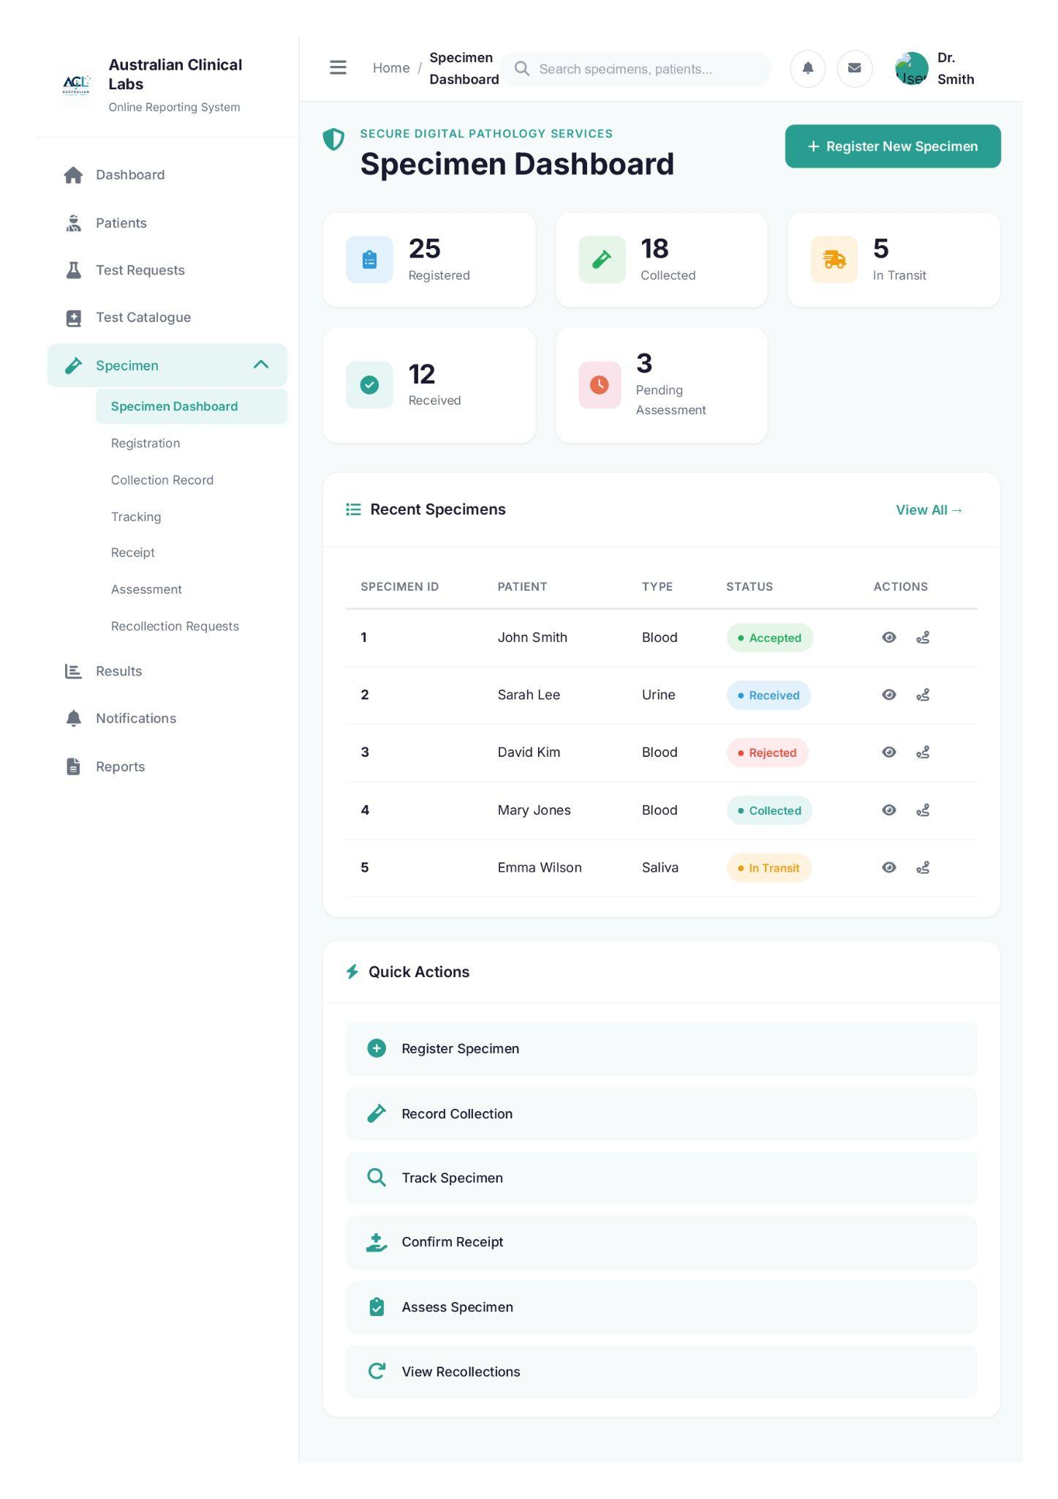
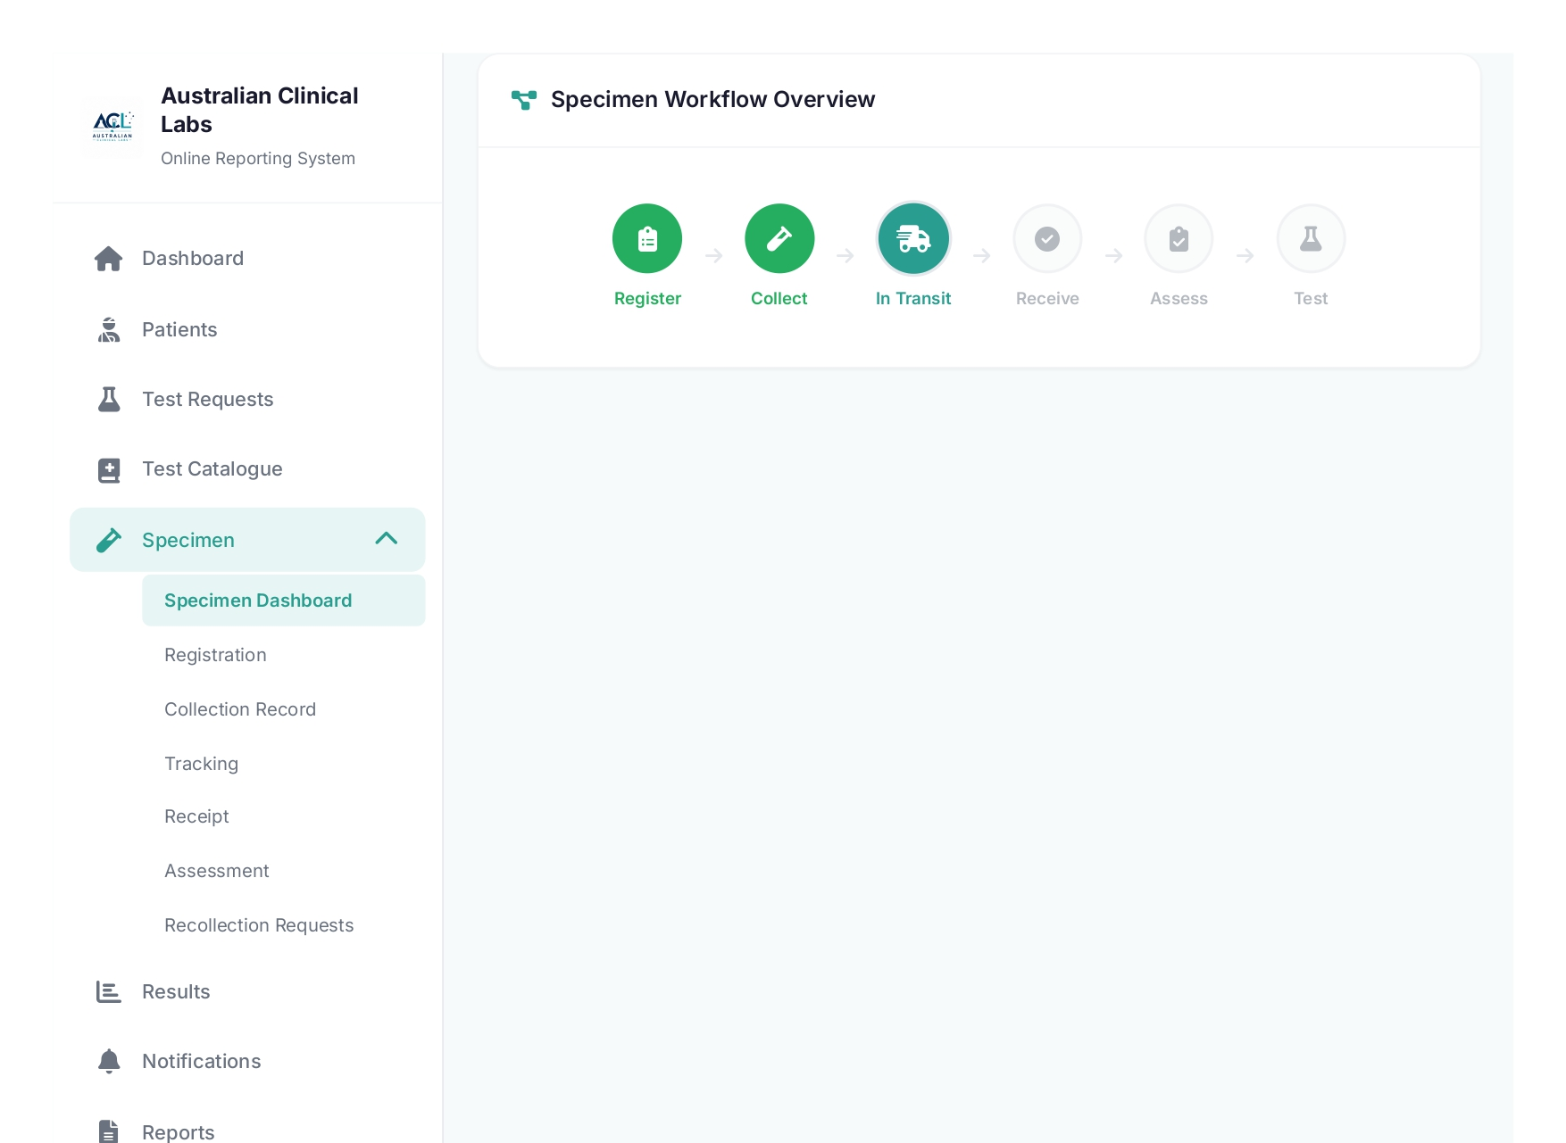

Index.php
<?php
require_once __DIR__ . '/../../config.php';
require_once __DIR__ . '/functions.php';

if (session_status() === PHP_SESSION_NONE) {
session_start();
}

if (
empty($_SESSION['authenticated']) ||
($_SESSION['portal'] ?? '') !== 'staff' ||
empty($_SESSION['mfa_verified']) ||
!in_array('specimen_collector', $_SESSION['roles'] ?? [], true)
) {
header('Location: ../auth/login.php?portal=staff');
exit;
}

$specimenStats = getSpecimenDashboardStats();
$recentSpecimens = getRecentSpecimens(8);
$currentUser = getCurrentDisplayName();

$statusColors = [
'Accepted' => 'status-accepted',
'Received' => 'status-received',
'Rejected' => 'status-rejected',
'Collected' => 'status-collected',
'In Transit' => 'status-transit',
'Pending Assessment' => 'status-pending',
'Registered' => 'status-registered',
];
?>
<!DOCTYPE html>
<html lang="en">
<head>
<meta charset="UTF-8">
<meta name="viewport" content="width=device-width, initial-scale=1.0">
<title>Specimen Dashboard - Australian Clinical Labs</title>
<link rel="stylesheet" href="../../css/specimen/styles.css">
<link href="https://fonts.googleapis.com/css2?family=Inter:wght@300;400;500;600;700&display=swap" rel="stylesheet">
<link rel="stylesheet" href="https://cdnjs.cloudflare.com/ajax/libs/font-awesome/6.4.0/css/all.min.css">
</head>
<body>
<div class="app-container">
<!-- Sidebar Navigation -->
<aside class="sidebar">
<div class="sidebar-header">
<div class="logo">
<img src="../../images/alc-logo.png" alt="ALC Logo">
<div class="logo-text">
<h1>Australian Clinical Labs</h1>
<span>Online Reporting System</span>
</div>
</div>
</div>

<nav class="sidebar-nav">
<ul class="nav-list">
<li class="nav-item">
<a href="#" class="nav-link">
<i class="fas fa-home"></i>
<span>Dashboard</span>
</a>
</li>
<li class="nav-item">
<a href="#" class="nav-link">
<i class="fas fa-user-injured"></i>
<span>Patients</span>
</a>
</li>
<li class="nav-item">
<a href="#" class="nav-link">
<i class="fas fa-flask"></i>
<span>Test Requests</span>
</a>
</li>
<li class="nav-item">
<a href="#" class="nav-link">
<i class="fas fa-book-medical"></i>
<span>Test Catalogue</span>
</a>
</li>

<!-- Specimen Section with Dropdown -->
<li class="nav-item has-submenu active">
<a href="#" class="nav-link submenu-toggle" onclick="toggleSubmenu(event)">
<i class="fas fa-vial"></i>
<span>Specimen</span>
<i class="fas fa-chevron-down submenu-icon"></i>
</a>
<ul class="submenu show">
<li><a href="index.php" class="submenu-link active">Specimen Dashboard</a></li>
<li><a href="registration.php" class="submenu-link">Registration</a></li>
<li><a href="collection.php" class="submenu-link">Collection Record</a></li>
<li><a href="tracking.php" class="submenu-link">Tracking</a></li>
<li><a href="receipt.php" class="submenu-link">Receipt</a></li>
<li><a href="assessment.php" class="submenu-link">Assessment</a></li>
<li><a href="recollection.php" class="submenu-link">Recollection Requests</a></li>
</ul>
</li>

<li class="nav-item">
<a href="#" class="nav-link">
<i class="fas fa-chart-bar"></i>
<span>Results</span>
</a>
</li>
<li class="nav-item">
<a href="#" class="nav-link">
<i class="fas fa-bell"></i>
<span>Notifications</span>
</a>
</li>
<li class="nav-item">
<a href="#" class="nav-link">
<i class="fas fa-file-alt"></i>
<span>Reports</span>
</a>
</li>
</ul>
</nav>
</aside>

<!-- Main Content Area -->
<main class="main-content">
<!-- Top Header -->
<header class="top-header">
<div class="header-left">
<button class="menu-toggle" onclick="toggleSidebar()">
<i class="fas fa-bars"></i>
</button>
<nav class="breadcrumb">
<a href="#">Home</a>
<span class="separator">/</span>
<span class="current">Specimen Dashboard</span>
</nav>
</div>
<div class="header-right">
<div class="search-bar">
<i class="fas fa-search"></i>
<input type="text" placeholder="Search specimens, patients...">
</div>
<div class="header-actions">
<button class="icon-btn"><i class="fas fa-bell"></i></button>
<button class="icon-btn"><i class="fas fa-envelope"></i></button>
<div class="user-profile">
<span><?= htmlspecialchars($currentUser, ENT_QUOTES, 'UTF-8') ?></span>
</div>
<a href="../auth/logout.php" class="btn btn-secondary" style="padding:0.7rem 1rem; margin-left:0.75rem;"><i class="fas fa-sign-out-alt"></i> Logout</a>
</div>
</div>
</header>

<!-- Dashboard Content -->
<div class="dashboard-content">
<!-- Page Title Section -->
<div class="page-header">
<div class="page-title">
<i class="fas fa-shield-alt"></i>
<div>
<h2>SECURE DIGITAL PATHOLOGY SERVICES</h2>
<h1>Specimen Dashboard</h1>
</div>
</div>
<a href="registration.php" class="btn btn-primary">
<i class="fas fa-plus"></i>
Register New Specimen
</a>
</div>

<!-- Quick Stats Cards -->
<div class="stats-grid">
<div class="stat-card">
<div class="stat-icon registered">
<i class="fas fa-clipboard-list"></i>
</div>
<div class="stat-info">
<span class="stat-value"><?php echo $specimenStats['registered']; ?></span>
<span class="stat-label">Registered</span>
</div>
</div>
<div class="stat-card">
<div class="stat-icon collected">
<i class="fas fa-vial"></i>
</div>
<div class="stat-info">
<span class="stat-value"><?php echo $specimenStats['collected']; ?></span>
<span class="stat-label">Collected</span>
</div>
</div>
<div class="stat-card">
<div class="stat-icon transit">
<i class="fas fa-shipping-fast"></i>
</div>
<div class="stat-info">
<span class="stat-value"><?php echo $specimenStats['in_transit']; ?></span>
<span class="stat-label">In Transit</span>
</div>
</div>
<div class="stat-card">
<div class="stat-icon received">
<i class="fas fa-check-circle"></i>
</div>
<div class="stat-info">
<span class="stat-value"><?php echo $specimenStats['received']; ?></span>
<span class="stat-label">Received</span>
</div>
</div>
<div class="stat-card">
<div class="stat-icon pending">
<i class="fas fa-clock"></i>
</div>
<div class="stat-info">
<span class="stat-value"><?php echo $specimenStats['pending_assessment']; ?></span>
<span class="stat-label">Pending Assessment</span>
</div>
</div>
</div>

<!-- Main Dashboard Grid -->
<div class="dashboard-grid">
<!-- Recent Specimens Table -->
<div class="dashboard-card specimens-table">
<div class="card-header">
<h3><i class="fas fa-list"></i> Recent Specimens</h3>
<a href="#" class="btn btn-text">View All →</a>
</div>
<div class="card-body">
<table class="data-table">
<thead>
<tr>
<th>Specimen ID</th>
<th>Patient</th>
<th>Type</th>
<th>Status</th>
<th>Actions</th>
</tr>
</thead>
<tbody>
<?php foreach ($recentSpecimens as $specimen): ?>
<tr>
<td><strong><?php echo $specimen['id']; ?></strong></td>
<td><?php echo $specimen['patient']; ?></td>
<td><?php echo $specimen['type']; ?></td>
<td>
<span class="status-badge <?php echo $statusColors[$specimen['status']]; ?>">
<?php echo $specimen['status']; ?>
</span>
</td>
<td>
<button class="btn-icon" title="View Details"><i class="fas fa-eye"></i></button>
<button class="btn-icon" title="Track"><i class="fas fa-route"></i></button>
</td>
</tr>
<?php endforeach; ?>
</tbody>
</table>
</div>
</div>

<!-- Quick Actions -->
<div class="dashboard-card quick-actions">
<div class="card-header">
<h3><i class="fas fa-bolt"></i> Quick Actions</h3>
</div>
<div class="card-body">
<div class="action-buttons">
<a href="registration.php" class="action-btn">
<i class="fas fa-plus-circle"></i>
<span>Register Specimen</span>
</a>
<a href="collection.php" class="action-btn">
<i class="fas fa-vial"></i>
<span>Record Collection</span>
</a>
<a href="tracking.php" class="action-btn">
<i class="fas fa-search"></i>
<span>Track Specimen</span>
</a>
<a href="receipt.php" class="action-btn">
<i class="fas fa-hand-holding-medical"></i>
<span>Confirm Receipt</span>
</a>
<a href="assessment.php" class="action-btn">
<i class="fas fa-clipboard-check"></i>
<span>Assess Specimen</span>
</a>
<a href="recollection.php" class="action-btn">
<i class="fas fa-redo"></i>
<span>View Recollections</span>
</a>
</div>
</div>
</div>
</div>

<!-- Workflow Status Section -->
<div class="dashboard-card workflow-section">
<div class="card-header">
<h3><i class="fas fa-project-diagram"></i> Specimen Workflow Overview</h3>
</div>
<div class="card-body">
<div class="workflow-steps">
<div class="workflow-step completed">
<div class="step-icon"><i class="fas fa-clipboard-list"></i></div>
<span class="step-label">Register</span>
</div>
<div class="workflow-arrow"><i class="fas fa-arrow-right"></i></div>
<div class="workflow-step completed">
<div class="step-icon"><i class="fas fa-vial"></i></div>
<span class="step-label">Collect</span>
</div>
<div class="workflow-arrow"><i class="fas fa-arrow-right"></i></div>
<div class="workflow-step active">
<div class="step-icon"><i class="fas fa-shipping-fast"></i></div>
<span class="step-label">In Transit</span>
</div>
<div class="workflow-arrow"><i class="fas fa-arrow-right"></i></div>
<div class="workflow-step">
<div class="step-icon"><i class="fas fa-check-circle"></i></div>
<span class="step-label">Receive</span>
</div>
<div class="workflow-arrow"><i class="fas fa-arrow-right"></i></div>
<div class="workflow-step">
<div class="step-icon"><i class="fas fa-clipboard-check"></i></div>
<span class="step-label">Assess</span>
</div>
<div class="workflow-arrow"><i class="fas fa-arrow-right"></i></div>
<div class="workflow-step">
<div class="step-icon"><i class="fas fa-flask"></i></div>
<span class="step-label">Test</span>
</div>
</div>
</div>
</div>
</div>
</main>
</div>

<script src="../../js/specimen/script.js"></script>
</body>
</html>

- Specimen Registration

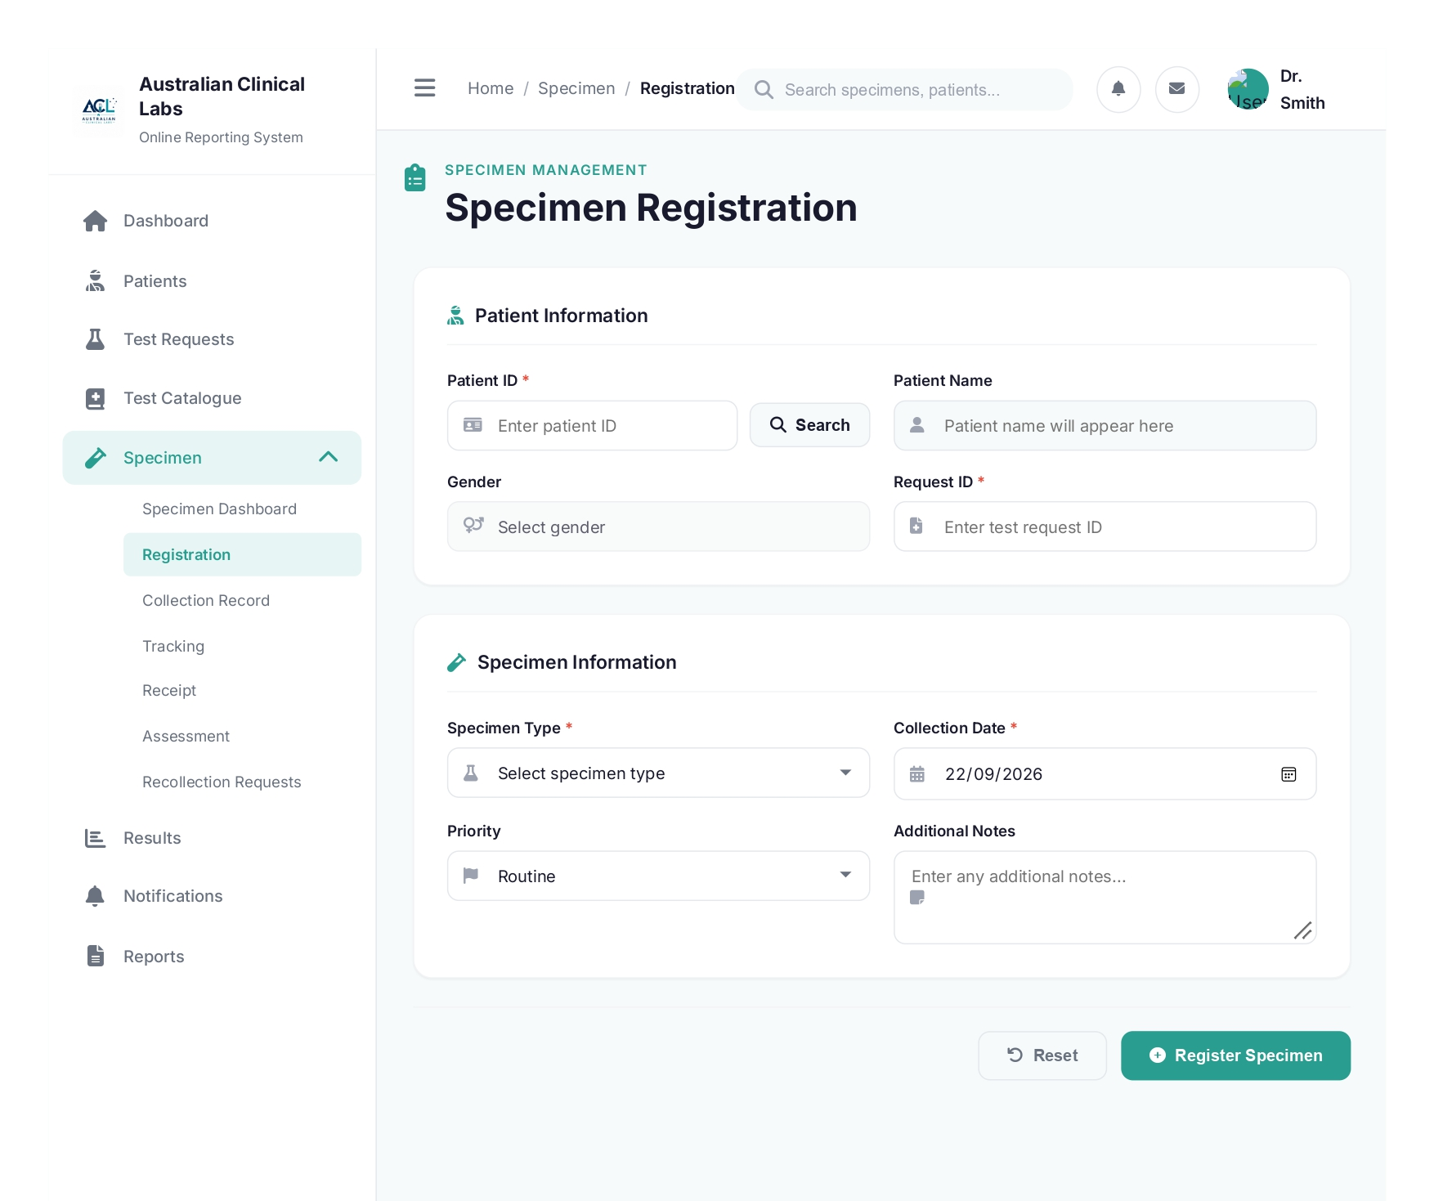

registration.php
<?php
require_once __DIR__ . '/functions.php';

if (session_status() === PHP_SESSION_NONE) {
session_start();
}

$pdo = db();
$sql = "SELECT * FROM specimen_registration";
$stmt = $pdo->query($sql);
$specimens = $stmt->fetchAll(PDO::FETCH_ASSOC);

$specimenTypes = [];
try {
$typeStmt = $pdo->query("SELECT type_id, type_name FROM specimen_types WHERE is_active = 1 ORDER BY type_name ASC");
$specimenTypes = $typeStmt->fetchAll(PDO::FETCH_ASSOC);
} catch (Throwable $e) {
error_log('Failed to load specimen types: ' . $e->getMessage());
}

$currentUser = getCurrentDisplayName();
?>
<!DOCTYPE html>
<html lang="en">
<head>
<meta charset="UTF-8">
<meta name="viewport" content="width=device-width, initial-scale=1.0">
<title>Specimen Registration - Australian Clinical Labs</title>
<link rel="stylesheet" href="../../css/specimen/styles.css">
<link rel="stylesheet" href="../../css/specimen/forms.css">
<link href="https://fonts.googleapis.com/css2?family=Inter:wght@300;400;500;600;700&display=swap" rel="stylesheet">
<link rel="stylesheet" href="https://cdnjs.cloudflare.com/ajax/libs/font-awesome/6.4.0/css/all.min.css">
</head>
<body>
<div class="app-container">
<!-- Sidebar Navigation -->
<aside class="sidebar">
<div class="sidebar-header">
<div class="logo">
<img src="../../images/alc-logo.png" alt="ALC Logo">
<div class="logo-text">
<h1>Australian Clinical Labs</h1>
<span>Online Reporting System</span>
</div>
</div>
</div>

<nav class="sidebar-nav">
<ul class="nav-list">
<li class="nav-item">
<a href="#" class="nav-link">
<i class="fas fa-home"></i>
<span>Dashboard</span>
</a>
</li>
<li class="nav-item">
<a href="#" class="nav-link">
<i class="fas fa-user-injured"></i>
<span>Patients</span>
</a>
</li>
<li class="nav-item">
<a href="#" class="nav-link">
<i class="fas fa-flask"></i>
<span>Test Requests</span>
</a>
</li>
<li class="nav-item">
<a href="#" class="nav-link">
<i class="fas fa-book-medical"></i>
<span>Test Catalogue</span>
</a>
</li>

<!-- Specimen Section with Dropdown -->
<li class="nav-item has-submenu active">
<a href="#" class="nav-link submenu-toggle" onclick="toggleSubmenu(event)">
<i class="fas fa-vial"></i>
<span>Specimen</span>
<i class="fas fa-chevron-down submenu-icon"></i>
</a>
<ul class="submenu show">
<li><a href="index.php" class="submenu-link">Specimen Dashboard</a></li>
<li><a href="registration.php" class="submenu-link active">Registration</a></li>
<li><a href="collection.php" class="submenu-link">Collection Record</a></li>
<li><a href="tracking.php" class="submenu-link">Tracking</a></li>
<li><a href="receipt.php" class="submenu-link">Receipt</a></li>
<li><a href="assessment.php" class="submenu-link">Assessment</a></li>
<li><a href="recollection.php" class="submenu-link">Recollection Requests</a></li>
</ul>
</li>

<li class="nav-item">
<a href="#" class="nav-link">
<i class="fas fa-chart-bar"></i>
<span>Results</span>
</a>
</li>
<li class="nav-item">
<a href="#" class="nav-link">
<i class="fas fa-bell"></i>
<span>Notifications</span>
</a>
</li>
<li class="nav-item">
<a href="#" class="nav-link">
<i class="fas fa-file-alt"></i>
<span>Reports</span>
</a>
</li>
</ul>
</nav>
</aside>

<!-- Main Content Area -->
<main class="main-content">
<!-- Top Header -->
<header class="top-header">
<div class="header-left">
<button class="menu-toggle" onclick="toggleSidebar()">
<i class="fas fa-bars"></i>
</button>
<nav class="breadcrumb">
<a href="index.php">Home</a>
<span class="separator">/</span>
<a href="index.php">Specimen</a>
<span class="separator">/</span>
<span class="current">Registration</span>
</nav>
</div>
<div class="header-right">
<div class="search-bar">
<i class="fas fa-search"></i>
<input type="text" placeholder="Search specimens, patients...">
</div>
<div class="header-actions">
<button class="icon-btn"><i class="fas fa-bell"></i></button>
<button class="icon-btn"><i class="fas fa-envelope"></i></button>
<div class="user-profile">
<span><?= htmlspecialchars($currentUser, ENT_QUOTES, 'UTF-8') ?></span>
</div>
<a href="../auth/logout.php" class="btn btn-secondary" style="padding:0.7rem 1rem; margin-left:0.75rem;"><i class="fas fa-sign-out-alt"></i> Logout</a>
</div>
</div>
</header>

<!-- Registration Content -->
<div class="dashboard-content">
<div class="page-header">
<div class="page-title">
<i class="fas fa-clipboard-list"></i>
<div>
<h2>SPECIMEN MANAGEMENT</h2>
<h1>Specimen Registration</h1>
</div>
</div>
</div>

<div class="form-container">
<form id="registrationForm" class="specimen-form">
<!-- Patient Information Section -->
<div class="form-section">
<h3><i class="fas fa-user-injured"></i> Patient Information</h3>
<div class="form-row">
<div class="form-group">
<label for="patientId">Patient ID <span class="required">*</span></label>
<div class="input-group">
<i class="fas fa-id-card"></i>
<input type="text" id="patientId" name="patient_id" placeholder="Enter patient ID" required>
<button type="button" class="btn btn-secondary" onclick="searchPatient()">
<i class="fas fa-search"></i> Search
</button>

</div>
</div>
<div class="form-group">
<label for="patientName">Patient Name</label>
<div class="input-group">
<i class="fas fa-user"></i>
<input type="text" id="patientName" name="patient_name" placeholder="Patient name will appear here" readonly>
</div>
</div>
</div>

<div class="form-row">
<div class="form-group">
<label for="gender">Gender</label>
<div class="input-group">
<i class="fas fa-venus-mars"></i>
<select id="gender" name="gender" disabled>
<option value="">Select gender</option>
<option value="male">Male</option>
<option value="female">Female</option>
<option value="other">Other</option>
</select>
</div>
</div>
<div class="form-group">
<label for="requestId">Request ID</label>
<div class="input-group">
<i class="fas fa-file-medical"></i>
<input type="text" id="requestId" name="request_id" placeholder="Optional test request ID">
</div>
</div>
</div>
</div>

<!-- Specimen Information Section -->
<div class="form-section">
<h3><i class="fas fa-vial"></i> Specimen Information</h3>
<div class="form-row">
<div class="form-group">
<label for="specimenType">Specimen Type <span class="required">*</span></label>
<div class="input-group">
<i class="fas fa-flask"></i>
<select id="specimenType" name="specimen_type" required>
<option value="">Select specimen type</option>
<?php foreach ($specimenTypes as $type): ?>
<option value="<?= htmlspecialchars((string) $type['type_id'], ENT_QUOTES, 'UTF-8') ?>"><?= htmlspecialchars($type['type_name'], ENT_QUOTES, 'UTF-8') ?></option>
<?php endforeach; ?>
</select>
</div>
</div>
<div class="form-group">
<label for="collectionDate">Collection Date <span class="required">*</span></label>
<div class="input-group">
<i class="fas fa-calendar-alt"></i>
<input type="date" id="collectionDate" name="collection_date" required>
</div>
</div>
</div>

<div class="form-row">
<div class="form-group">
<label for="registrationDate">Registration Date <span class="required">*</span></label>
<div class="input-group">
<i class="fas fa-calendar-check"></i>
<input type="date" id="registrationDate" name="registration_date" required>
</div>
</div>
<div class="form-group">
<label for="priority">Priority</label>
<div class="input-group">
<i class="fas fa-flag"></i>
<select id="priority" name="priority">
<option value="routine">Routine</option>
<option value="urgent">Urgent</option>
<option value="stat">STAT</option>
</select>
</div>
</div>
</div>

<div class="form-row">
<div class="form-group">
<label for="notes">Additional Notes</label>
<div class="input-group">
<i class="fas fa-sticky-note"></i>
<textarea id="notes" name="notes" rows="3" placeholder="Enter any additional notes..."></textarea>
</div>
</div>
</div>
</div>

<!-- Action Buttons -->
<div class="form-actions">
<button type="reset" class="btn btn-outline">
<i class="fas fa-undo"></i> Reset
</button>
<button type="submit" class="btn btn-primary">
<i class="fas fa-plus-circle"></i> Register Specimen
</button>
</div>
</form>

<!-- Registration Result (Hidden by default) -->
<div id="registrationResult" class="registration-result" style="display: none;">
<div class="result-header">
<i class="fas fa-check-circle"></i>
<h3>Specimen Registered Successfully</h3>
</div>
<div class="result-details">
<div class="detail-row">
<span class="detail-label">Specimen ID:</span>
<span class="detail-value" id="resultSpecimenId">-</span>
</div>
<div class="detail-row">
<span class="detail-label">Barcode ID:</span>
<span class="detail-value" id="resultBarcodeId">-</span>
</div>
<div class="detail-row">
<span class="detail-label">Status:</span>
<span class="detail-value">
<span class="status-badge status-registered">Registered</span>
</span>
</div>
</div>
<div class="result-actions">
<button class="btn btn-primary" onclick="printBarcode()">
<i class="fas fa-print"></i> Print Barcode
</button>
<button class="btn btn-secondary" onclick="registerAnother()">
<i class="fas fa-plus"></i> Register Another
</button>
</div>
</div>
</div>
</div>
</main>
</div>

<script src="../../js/specimen/forms.js"></script>
<script src="../../js/specimen/script.js"></script>
</body>
</html>

- Specimen Collection

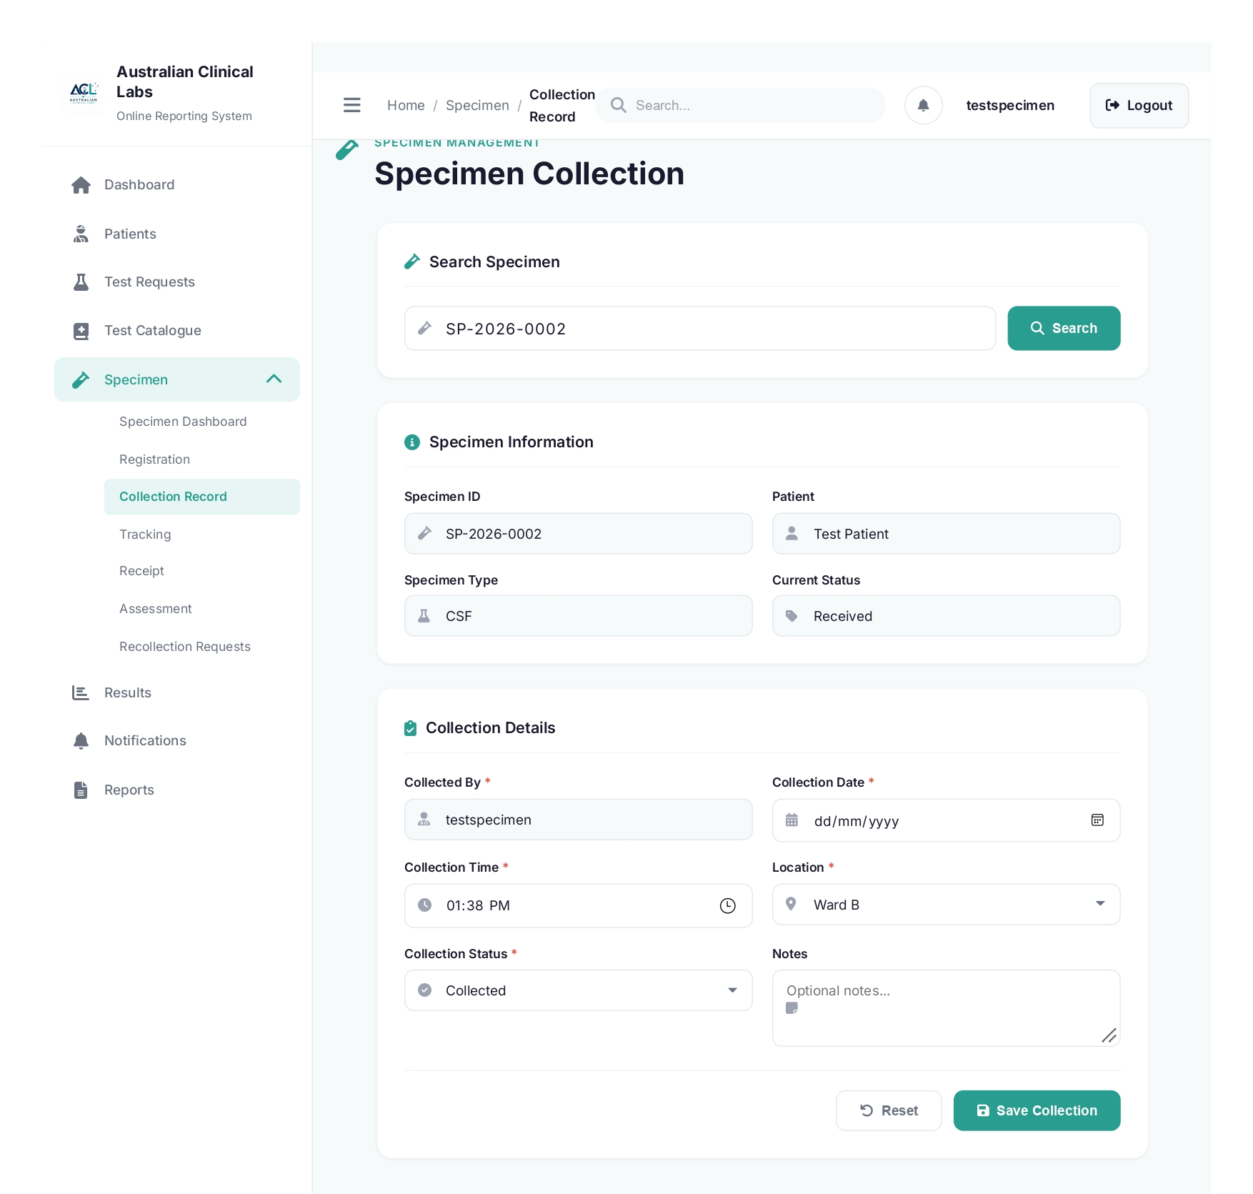

collection.php
<?php
require_once __DIR__ . '/functions.php';

if (session_status() === PHP_SESSION_NONE) {
session_start();
}

if (!isset($_SESSION['user_id'])) {
header('Location: ../auth/login.php?portal=staff');
exit;
}

$pdo = db();
$currentUser = getCurrentDisplayName();
?>

<!DOCTYPE html>
<html lang="en">
<head>
<meta charset="UTF-8">
<meta name="viewport" content="width=device-width, initial-scale=1.0">
<title>Specimen Collection - Australian Clinical Labs</title>
<link rel="stylesheet" href="../../css/specimen/styles.css">
<link rel="stylesheet" href="../../css/specimen/forms.css">
<link href="https://fonts.googleapis.com/css2?family=Inter:wght@300;400;500;600;700&display=swap" rel="stylesheet">
<link rel="stylesheet" href="https://cdnjs.cloudflare.com/ajax/libs/font-awesome/6.4.0/css/all.min.css">
</head>
<body>
<div class="app-container">
<aside class="sidebar">
<div class="sidebar-header">
<div class="logo">
<img src="../../images/alc-logo.png" alt="ALC Logo">
<div class="logo-text"><h1>Australian Clinical Labs</h1><span>Online Reporting System</span></div>
</div>
</div>
<nav class="sidebar-nav">
<ul class="nav-list">
<li class="nav-item"><a href="#" class="nav-link"><i class="fas fa-home"></i><span>Dashboard</span></a></li>
<li class="nav-item"><a href="#" class="nav-link"><i class="fas fa-user-injured"></i><span>Patients</span></a></li>
<li class="nav-item"><a href="#" class="nav-link"><i class="fas fa-flask"></i><span>Test Requests</span></a></li>
<li class="nav-item"><a href="#" class="nav-link"><i class="fas fa-book-medical"></i><span>Test Catalogue</span></a></li>
<li class="nav-item has-submenu active">
<a href="#" class="nav-link submenu-toggle" onclick="toggleSubmenu(event)">
<i class="fas fa-vial"></i><span>Specimen</span><i class="fas fa-chevron-down submenu-icon"></i>
</a>
<ul class="submenu show">
<li><a href="index.php" class="submenu-link">Specimen Dashboard</a></li>
<li><a href="registration.php" class="submenu-link">Registration</a></li>
<li><a href="collection.php" class="submenu-link active">Collection Record</a></li>
<li><a href="tracking.php" class="submenu-link">Tracking</a></li>
<li><a href="receipt.php" class="submenu-link">Receipt</a></li>
<li><a href="assessment.php" class="submenu-link">Assessment</a></li>
<li><a href="recollection.php" class="submenu-link">Recollection Requests</a></li>
</ul>
</li>
<li class="nav-item"><a href="#" class="nav-link"><i class="fas fa-chart-bar"></i><span>Results</span></a></li>
<li class="nav-item"><a href="#" class="nav-link"><i class="fas fa-bell"></i><span>Notifications</span></a></li>
<li class="nav-item"><a href="#" class="nav-link"><i class="fas fa-file-alt"></i><span>Reports</span></a></li>
</ul>
</nav>
</aside>
<main class="main-content">
<header class="top-header">
<div class="header-left">
<button class="menu-toggle" onclick="toggleSidebar()"><i class="fas fa-bars"></i></button>
<nav class="breadcrumb"><a href="index.php">Home</a><span class="separator">/</span><a href="index.php">Specimen</a><span class="separator">/</span><span class="current">Collection Record</span></nav>
</div>
<div class="header-right">
<div class="search-bar"><i class="fas fa-search"></i><input type="text" placeholder="Search..."></div>
<div class="header-actions"><button class="icon-btn"><i class="fas fa-bell"></i></button><div class="user-profile"><span><?= htmlspecialchars($currentUser, ENT_QUOTES, 'UTF-8') ?></span></div><a href="../auth/logout.php" class="btn btn-secondary" style="padding:0.7rem 1rem; margin-left:0.75rem;"><i class="fas fa-sign-out-alt"></i> Logout</a></div>
</div>
</header>
<div class="dashboard-content">
<div class="page-header"><div class="page-title"><i class="fas fa-vial"></i><div><h2>SPECIMEN MANAGEMENT</h2><h1>Specimen Collection</h1></div></div></div>
<div class="form-container">
<div class="form-section"><h3><i class="fas fa-vial"></i> Search Specimen</h3><div class="scan-input-group"><div class="input-group" style="flex:1;"><i class="fas fa-vial"></i><input type="text" id="scanSpecimenId" placeholder="Enter specimen ID..." autofocus></div><button type="button" class="btn btn-primary" onclick="scanSpecimen()"><i class="fas fa-search"></i> Search</button></div></div>
<form id="collectionForm" class="specimen-form" onsubmit="handleCollection(event)">
<div id="specimenInfo" class="form-section" style="display:none;"><h3><i class="fas fa-info-circle"></i> Specimen Information</h3><div class="form-row"><div class="form-group"><label>Specimen ID</label><div class="input-group"><i class="fas fa-vial"></i><input type="text" id="specimenId" name="specimen_id" readonly></div></div><div class="form-group"><label>Patient</label><div class="input-group"><i class="fas fa-user"></i><input type="text" id="patientName" readonly></div></div></div><div class="form-row"><div class="form-group"><label>Specimen Type</label><div class="input-group"><i class="fas fa-flask"></i><input type="text" id="specimenType" readonly></div></div><div class="form-group"><label>Current Status</label><div class="input-group"><i class="fas fa-tag"></i><input type="text" id="currentStatus" readonly></div></div></div></div>
<div class="form-section"><h3><i class="fas fa-clipboard-check"></i> Collection Details</h3><div class="form-row"><div class="form-group"><label for="collectedBy">Collected By <span class="required">*</span></label><div class="input-group"><i class="fas fa-user-md"></i><input type="text" id="collectedBy" name="collected_by" value="<?= htmlspecialchars($currentUser, ENT_QUOTES, 'UTF-8') ?>" readonly required></div></div><div class="form-group"><label for="collectionDate">Collection Date <span class="required">*</span></label><div class="input-group"><i class="fas fa-calendar-alt"></i><input type="date" id="collectionDate" name="collection_date" required></div></div></div><div class="form-row"><div class="form-group"><label for="collectionTime">Collection Time <span class="required">*</span></label><div class="input-group"><i class="fas fa-clock"></i><input type="time" id="collectionTime" name="collection_time" required></div></div><div class="form-group"><label for="location">Location <span class="required">*</span></label><div class="input-group"><i class="fas fa-map-marker-alt"></i><select id="location" name="location" required><option value="">Select location</option><option value="Collection Room 1">Collection Room 1</option><option value="Collection Room 2">Collection Room 2</option><option value="Ward A">Ward A</option><option value="Ward B">Ward B</option><option value="Emergency">Emergency</option></select></div></div></div><div class="form-row"><div class="form-group"><label for="collectionStatus">Collection Status <span class="required">*</span></label><div class="input-group"><i class="fas fa-check-circle"></i><select id="collectionStatus" name="collection_status" required><option value="Collected">Collected</option><option value="Not Collected">Not Collected</option><option value="Failed">Failed</option></select></div></div><div class="form-group"><label for="collectionNotes">Notes</label><div class="input-group"><i class="fas fa-sticky-note"></i><textarea id="collectionNotes" name="notes" rows="2" placeholder="Optional notes..."></textarea></div></div></div><div class="form-actions"><button type="reset" class="btn btn-outline"><i class="fas fa-undo"></i> Reset</button><button type="submit" class="btn btn-primary"><i class="fas fa-save"></i> Save Collection</button></div>
</form>
</div>
</div>
</main>
</div>
<script src="../../js/specimen/script.js"></script>
<script>
function scanSpecimen() {
const specimenId = document.getElementById('scanSpecimenId').value.trim();
if (!specimenId) {
alert('Please enter a specimen ID');
return;
}

fetch('fetch-specimen.php?specimen_id=' + encodeURIComponent(specimenId))
.then(res => res.json())
.then(data => {
if (!data.success) {
alert(data.error || 'Specimen not found in database');
return;
}
document.getElementById('specimenId').value = data.specimen_id;
document.getElementById('patientName').value = data.patient;
document.getElementById('specimenType').value = data.type;
document.getElementById('currentStatus').value = data.status;
document.getElementById('specimenInfo').style.display = 'block';
document.getElementById('collectedBy').focus();
})
.catch(err => {
console.error(err);
alert('Cannot connect to database');
});
}

function handleCollection(event) {
event.preventDefault(); // stop the native reload

const specimenId = document.getElementById('specimenId').value.trim();
if (!specimenId) {
alert('Please search for a specimen before saving');
return;
}

const formData = new FormData(event.target);

fetch('save_collection.php', {
method: 'POST',
body: formData
})
.then(res => res.json())
.then(data => {
if (data.success) {
alert('Collection saved successfully');
event.target.reset();
document.getElementById('specimenInfo').style.display = 'none';
document.getElementById('scanSpecimenId').value = '';
} else {
alert(data.error || 'Failed to save collection');
}
})
.catch(err => {
console.error(err);
alert('Cannot connect to server');
});
}
</script>

</body>
</html>
lder="Optional notes..."></textarea></div></div></div></div>
<div class="form-actions"><button type="reset" class="btn btn-outline"><i class="fas fa-undo"></i> Reset</button><button type="submit" class="btn btn-primary"><i class="fas fa-save"></i> Save Collection</button></div>
</form>
</div>
</div>
</main>
</div>
<script src="../../js/specimen/script.js"></script>
<script>
function scanSpecimen() {
const specimenId = document.getElementById('scanSpecimenId').value.trim();
if (!specimenId) {
alert('Please enter a specimen ID');
return;
}

fetch('fetch-specimen.php?specimen_id=' + encodeURIComponent(specimenId))
.then(res => res.json())
.then(data => {
if (!data.success) {
alert(data.error || 'Specimen not found in database');
return;
}
document.getElementById('specimenId').value = data.specimen_id;
document.getElementById('patientName').value = data.patient;
document.getElementById('specimenType').value = data.type;
document.getElementById('currentStatus').value = data.status;
document.getElementById('specimenInfo').style.display = 'block';
document.getElementById('collectedBy').focus();
})
.catch(err => {
console.error(err);
alert('Cannot connect to database');
});
}

function handleCollection(event) {
event.preventDefault(); // stop the native reload

const specimenId = document.getElementById('specimenId').value.trim();
if (!specimenId) {
alert('Please search for a specimen before saving');
return;
}

const formData = new FormData(event.target);

fetch('save_collection.php', {
method: 'POST',
body: formData
})
.then(res => res.json())
.then(data => {
if (data.success) {
alert('Collection saved successfully');
event.target.reset();
document.getElementById('specimenInfo').style.display = 'none';
document.getElementById('scanSpecimenId').value = '';
} else {
alert(data.error || 'Failed to save collection');
}
})
.catch(err => {
console.error(err);
alert('Cannot connect to server');
});
}
</script>

</body>
</html>

- Specimen Tracking
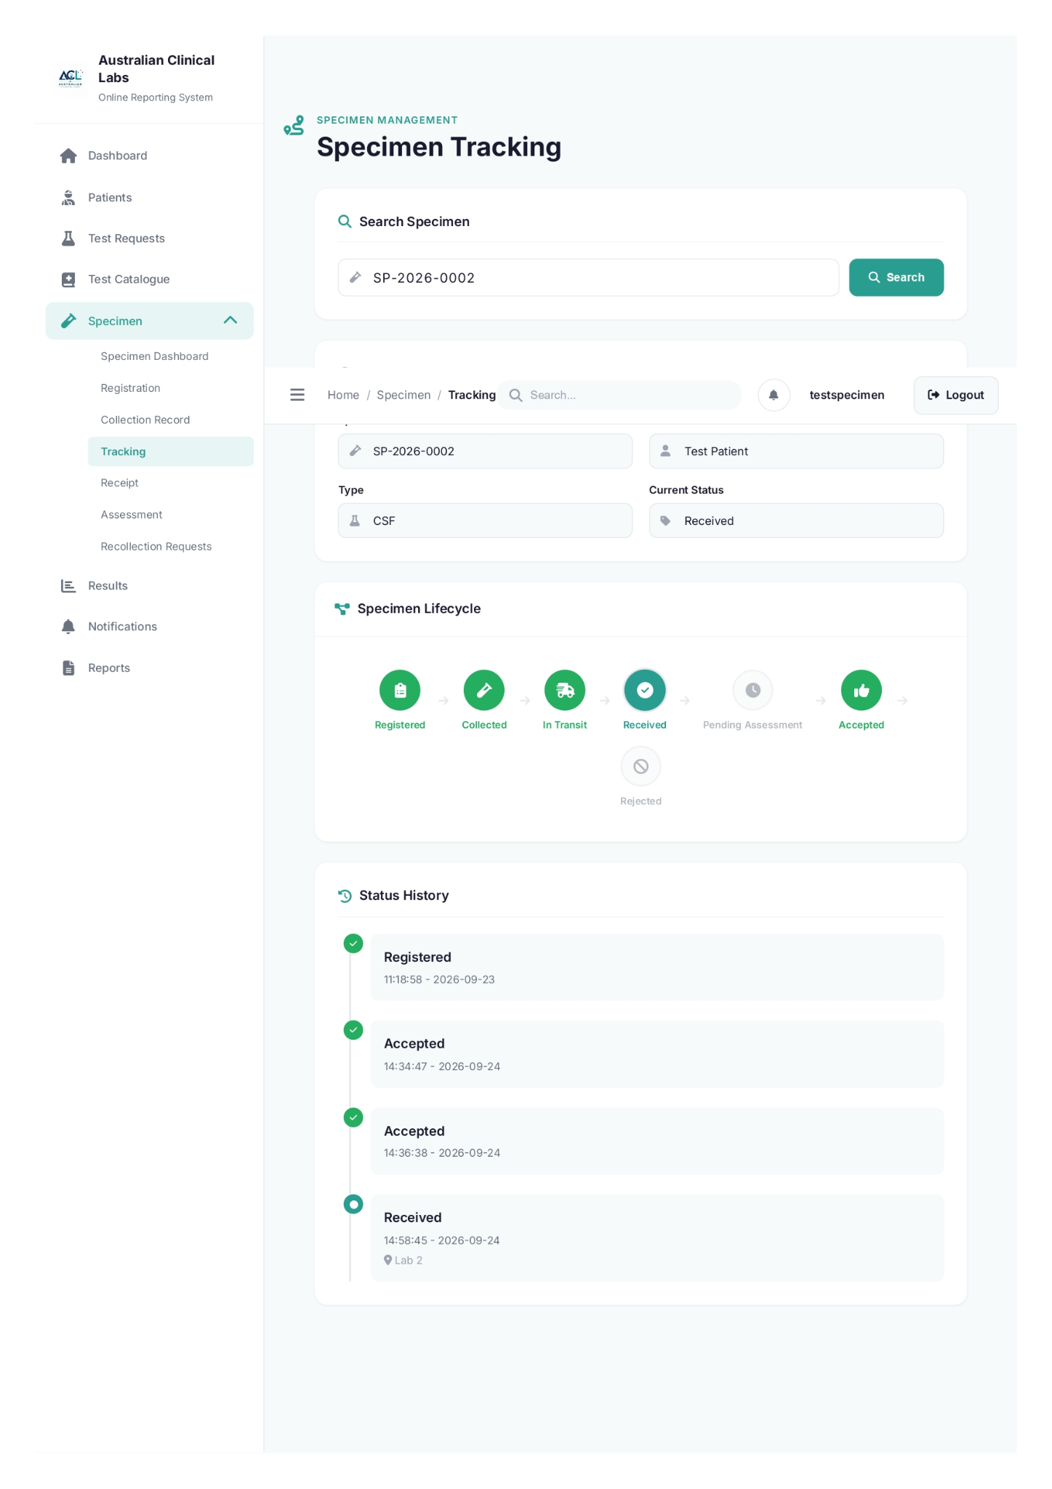

tracking.php

<?php
session_start();
require_once __DIR__ . '/functions.php';
$currentUser = getCurrentDisplayName();
?>
<!DOCTYPE html>
<html lang="en">
<head>
<meta charset="UTF-8">
<meta name="viewport" content="width=device-width, initial-scale=1.0">
<title>Specimen Tracking - Australian Clinical Labs</title>
<link rel="stylesheet" href="../../css/specimen/styles.css">
<link rel="stylesheet" href="../../css/specimen/forms.css">
<link href="https://fonts.googleapis.com/css2?family=Inter:wght@300;400;500;600;700&display=swap" rel="stylesheet">
<link rel="stylesheet" href="https://cdnjs.cloudflare.com/ajax/libs/font-awesome/6.4.0/css/all.min.css">
</head>
<body>
<div class="app-container">
<aside class="sidebar">
<div class="sidebar-header">
<div class="logo">
<img src="../../images/alc-logo.png" alt="ALC Logo">
<div class="logo-text"><h1>Australian Clinical Labs</h1><span>Online Reporting System</span></div>
</div>
</div>
<nav class="sidebar-nav">
<ul class="nav-list">
<li class="nav-item"><a href="#" class="nav-link"><i class="fas fa-home"></i><span>Dashboard</span></a></li>
<li class="nav-item"><a href="#" class="nav-link"><i class="fas fa-user-injured"></i><span>Patients</span></a></li>
<li class="nav-item"><a href="#" class="nav-link"><i class="fas fa-flask"></i><span>Test Requests</span></a></li>
<li class="nav-item"><a href="#" class="nav-link"><i class="fas fa-book-medical"></i><span>Test Catalogue</span></a></li>
<li class="nav-item has-submenu active">
<a href="#" class="nav-link submenu-toggle" onclick="toggleSubmenu(event)">
<i class="fas fa-vial"></i><span>Specimen</span><i class="fas fa-chevron-down submenu-icon"></i>
</a>
<ul class="submenu show">
<li><a href="index.php" class="submenu-link">Specimen Dashboard</a></li>
<li><a href="registration.php" class="submenu-link">Registration</a></li>
<li><a href="collection.php" class="submenu-link">Collection Record</a></li>
<li><a href="tracking.php" class="submenu-link active">Tracking</a></li>
<li><a href="receipt.php" class="submenu-link">Receipt</a></li>
<li><a href="assessment.php" class="submenu-link">Assessment</a></li>
<li><a href="recollection.php" class="submenu-link">Recollection Requests</a></li>
</ul>
</li>
<li class="nav-item"><a href="#" class="nav-link"><i class="fas fa-chart-bar"></i><span>Results</span></a></li>
<li class="nav-item"><a href="#" class="nav-link"><i class="fas fa-bell"></i><span>Notifications</span></a></li>
<li class="nav-item"><a href="#" class="nav-link"><i class="fas fa-file-alt"></i><span>Reports</span></a></li>
</ul>
</nav>
</aside>
<main class="main-content">
<header class="top-header">
<div class="header-left">
<button class="menu-toggle" onclick="toggleSidebar()"><i class="fas fa-bars"></i></button>
<nav class="breadcrumb"><a href="index.php">Home</a><span class="separator">/</span><a href="index.php">Specimen</a><span class="separator">/</span><span class="current">Tracking</span></nav>
</div>
<div class="header-right">
<div class="search-bar"><i class="fas fa-search"></i><input type="text" placeholder="Search..."></div>
<div class="header-actions"><button class="icon-btn"><i class="fas fa-bell"></i></button><div class="user-profile"><span><?= htmlspecialchars($currentUser, ENT_QUOTES, 'UTF-8') ?></span></div><a href="../auth/logout.php" class="btn btn-secondary" style="padding:0.7rem 1rem; margin-left:0.75rem;"><i class="fas fa-sign-out-alt"></i> Logout</a></div>
</div>
</header>
<div class="dashboard-content">
<div class="page-header"><div class="page-title"><i class="fas fa-route"></i><div><h2>SPECIMEN MANAGEMENT</h2><h1>Specimen Tracking</h1></div></div></div>
<div class="form-container">
<div class="form-section"><h3><i class="fas fa-search"></i> Search Specimen</h3><div class="scan-input-group"><div class="input-group" style="flex:1;"><i class="fas fa-vial"></i><input type="text" id="trackingSpecimenIdInput" placeholder="Enter specimen ID" autofocus></div><button type="button" class="btn btn-primary" onclick="searchTracking()"><i class="fas fa-search"></i> Search</button></div></div>
<div id="trackingResult" style="display:none;">
<div class="form-section"><h3><i class="fas fa-info-circle"></i> Specimen Details</h3><div class="form-row"><div class="form-group"><label>Specimen ID</label><div class="input-group"><i class="fas fa-vial"></i><input type="text" id="trackingSpecimenId" readonly></div></div><div class="form-group"><label>Patient</label><div class="input-group"><i class="fas fa-user"></i><input type="text" id="trackingPatient" readonly></div></div></div><div class="form-row"><div class="form-group"><label>Type</label><div class="input-group"><i class="fas fa-flask"></i><input type="text" id="trackingType" readonly></div></div><div class="form-group"><label>Current Status</label><div class="input-group"><i class="fas fa-tag"></i><input type="text" id="trackingCurrentStatus" readonly></div></div></div></div>
<div class="dashboard-card workflow-section">
<div class="card-header"><h3><i class="fas fa-project-diagram"></i> Specimen Lifecycle</h3></div>
<div class="card-body">
<div id="trackingWorkflow" class="workflow-steps"></div>
</div>
</div>
<div class="form-section"><h3><i class="fas fa-history"></i> Status History</h3><div id="trackingTimeline" class="timeline"></div></div>
</div>
</div>
</div>
</main>
</div>

<script src="../../js/specimen/script.js"></script>
<script>
function renderWorkflow(status, history) {
const workflow = document.getElementById('trackingWorkflow');
if (!workflow) return;

const orderedStatuses = ['Registered', 'Collected', 'In Transit', 'Received', 'Pending Assessment', 'Accepted', 'Rejected'];
const currentStatus = status || 'Registered';
const currentIndex = orderedStatuses.indexOf(currentStatus);
const knownStatuses = new Set((history || []).map(event => event.status));

workflow.innerHTML = '';

orderedStatuses.forEach((stepStatus, index) => {
const step = document.createElement('div');
let state = 'pending';

if (index < currentIndex || knownStatuses.has(stepStatus)) {
state = 'completed';
}

if (stepStatus === currentStatus) {
state = 'active';
}

step.className = `workflow-step ${state}`;
step.innerHTML = `
<div class="step-icon"><i class="fas ${stepStatus === 'Registered' ? 'fa-clipboard-list' : stepStatus === 'Collected' ? 'fa-vial' : stepStatus === 'In Transit' ? 'fa-shipping-fast' : stepStatus === 'Received' ? 'fa-check-circle' : stepStatus === 'Pending Assessment' ? 'fa-clock' : stepStatus === 'Accepted' ? 'fa-thumbs-up' : 'fa-ban'}"></i></div>
<span class="step-label">${stepStatus}</span>
`;

workflow.appendChild(step);

if (index < orderedStatuses.length - 1) {
const arrow = document.createElement('div');
arrow.className = 'workflow-arrow';
arrow.innerHTML = '<i class="fas fa-arrow-right"></i>';
workflow.appendChild(arrow);
}
});
}

function searchTracking() {
const specimenId = document.getElementById('trackingSpecimenIdInput').value.trim();

if (!specimenId) {
alert('Please enter a specimen ID');
return;
}

fetch('fetch-tracking.php?specimen_id=' + encodeURIComponent(specimenId))
.then(res => res.json())
.then(data => {
if (data.success) {
document.getElementById('trackingSpecimenId').value = data.specimen.specimen_id;
document.getElementById('trackingPatient').value = data.specimen.patient;
document.getElementById('trackingType').value = data.specimen.type;
document.getElementById('trackingCurrentStatus').value = data.specimen.status;

renderWorkflow(data.specimen.status, data.history);

const timeline = document.getElementById('trackingTimeline');
timeline.innerHTML = '';

data.history.forEach((event, i) => {
const isLast = i === data.history.length - 1;
const div = document.createElement('div');
div.className = `timeline-item ${isLast ? 'active' : 'completed'}`;
div.innerHTML = `
<div class="timeline-marker">
${isLast ? '<i class="fas fa-circle"></i>' : '<i class="fas fa-check"></i>'}
</div>
<div class="timeline-content">
<div class="timeline-title">${event.status}</div>
<div class="timeline-time">${event.time} - ${event.date}</div>
${event.location ? `<div class="timeline-location"><i class="fas fa-map-marker-alt"></i> ${event.location}</div>` : ''}
</div>
`;
timeline.appendChild(div);
});

document.getElementById('trackingResult').style.display = 'block';
} else {
alert(data.error || 'Specimen not found');
}
})
.catch(err => {
console.error(err);
alert('Cannot fetch tracking data');
});
}
</script>
</body>
</html>

- Specimen Receipt

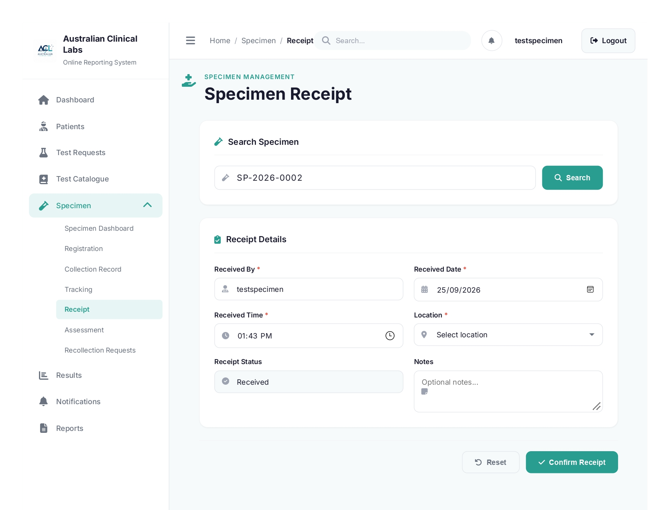

receipt.php
<?php
if (session_status() === PHP_SESSION_NONE) {
session_start();
}

require_once __DIR__ . '/functions.php';

if (
empty($_SESSION['authenticated']) ||
($_SESSION['portal'] ?? '') !== 'staff' ||
empty($_SESSION['mfa_verified']) ||
!in_array('specimen_collector', $_SESSION['roles'] ?? [], true)
) {
header('Location: ../auth/login.php?portal=staff');
exit;
}

$currentUser = getCurrentDisplayName();
?>
<!DOCTYPE html>
<html lang="en">
<head>
<meta charset="UTF-8">
<meta name="viewport" content="width=device-width, initial-scale=1.0">
<title>Specimen Receipt - Australian Clinical Labs</title>
<link rel="stylesheet" href="../../css/specimen/styles.css">
<link rel="stylesheet" href="../../css/specimen/forms.css">
<link href="https://fonts.googleapis.com/css2?family=Inter:wght@300;400;500;600;700&display=swap" rel="stylesheet">
<link rel="stylesheet" href="https://cdnjs.cloudflare.com/ajax/libs/font-awesome/6.4.0/css/all.min.css">
</head>
<body>
<div class="app-container">
<aside class="sidebar">
<div class="sidebar-header">
<div class="logo"><img src="../../images/alc-logo.png" alt="ALC Logo"><div class="logo-text"><h1>Australian Clinical Labs</h1><span>Online Reporting System</span></div></div>
</div>
<nav class="sidebar-nav">
<ul class="nav-list">
<li class="nav-item"><a href="#" class="nav-link"><i class="fas fa-home"></i><span>Dashboard</span></a></li>
<li class="nav-item"><a href="#" class="nav-link"><i class="fas fa-user-injured"></i><span>Patients</span></a></li>
<li class="nav-item"><a href="#" class="nav-link"><i class="fas fa-flask"></i><span>Test Requests</span></a></li>
<li class="nav-item"><a href="#" class="nav-link"><i class="fas fa-book-medical"></i><span>Test Catalogue</span></a></li>
<li class="nav-item has-submenu active"><a href="#" class="nav-link submenu-toggle" onclick="toggleSubmenu(event)"><i class="fas fa-vial"></i><span>Specimen</span><i class="fas fa-chevron-down submenu-icon"></i></a>
<ul class="submenu show">
<li><a href="index.php" class="submenu-link">Specimen Dashboard</a></li>
<li><a href="registration.php" class="submenu-link">Registration</a></li>
<li><a href="collection.php" class="submenu-link">Collection Record</a></li>
<li><a href="tracking.php" class="submenu-link">Tracking</a></li>
<li><a href="receipt.php" class="submenu-link active">Receipt</a></li>
<li><a href="assessment.php" class="submenu-link">Assessment</a></li>
<li><a href="recollection.php" class="submenu-link">Recollection Requests</a></li>
</ul>
</li>
<li class="nav-item"><a href="#" class="nav-link"><i class="fas fa-chart-bar"></i><span>Results</span></a></li>
<li class="nav-item"><a href="#" class="nav-link"><i class="fas fa-bell"></i><span>Notifications</span></a></li>
<li class="nav-item"><a href="#" class="nav-link"><i class="fas fa-file-alt"></i><span>Reports</span></a></li>
</ul>
</nav>
</aside>
<main class="main-content">
<header class="top-header">
<div class="header-left"><button class="menu-toggle" onclick="toggleSidebar()"><i class="fas fa-bars"></i></button><nav class="breadcrumb"><a href="index.php">Home</a><span class="separator">/</span><a href="index.php">Specimen</a><span class="separator">/</span><span class="current">Receipt</span></nav></div>
<div class="header-right"><div class="search-bar"><i class="fas fa-search"></i><input type="text" placeholder="Search..."></div><div class="header-actions"><button class="icon-btn"><i class="fas fa-bell"></i></button><div class="user-profile"><span><?= htmlspecialchars($currentUser, ENT_QUOTES, 'UTF-8') ?></span></div><a href="../auth/logout.php" class="btn btn-secondary" style="padding:0.7rem 1rem; margin-left:0.75rem;"><i class="fas fa-sign-out-alt"></i> Logout</a></div></div>
</header>
<div class="dashboard-content">
<div class="page-header"><div class="page-title"><i class="fas fa-hand-holding-medical"></i><div><h2>SPECIMEN MANAGEMENT</h2><h1>Specimen Receipt</h1></div></div></div>
<div class="form-container">
<div class="form-section"><h3><i class="fas fa-vial"></i> Search Specimen</h3><div class="scan-input-group"><div class="input-group" style="flex:1;"><i class="fas fa-vial"></i><input type="text" id="receiptSpecimenIdInput" placeholder="Enter specimen ID..." autofocus></div><button type="button" class="btn btn-primary" onclick="scanReceipt()"><i class="fas fa-search"></i> Search</button></div></div>
<form id="receiptForm" class="specimen-form" onsubmit="handleReceipt(event)">
<div id="receiptSpecimenInfo" class="form-section" style="display:none;"><h3><i class="fas fa-info-circle"></i> Specimen Information</h3><div class="form-row"><div class="form-group"><label>Specimen ID</label><div class="input-group"><i class="fas fa-vial"></i><input type="text" id="receiptSpecimenId" name="specimen_id" readonly></div></div><div class="form-group"><label>Patient</label><div class="input-group"><i class="fas fa-user"></i><input type="text" id="receiptPatientName" readonly></div></div></div><div class="form-row"><div class="form-group"><label>Specimen Type</label><div class="input-group"><i class="fas fa-flask"></i><input type="text" id="receiptSpecimenType" readonly></div></div><div class="form-group"><label>Current Status</label><div class="input-group"><i class="fas fa-tag"></i><input type="text" id="receiptCurrentStatus" value="In Transit" readonly></div></div></div></div>
<div class="form-section"><h3><i class="fas fa-clipboard-check"></i> Receipt Details</h3><div class="form-row"><div class="form-group"><label for="receivedBy">Received By <span class="required">*</span></label><div class="input-group"><i class="fas fa-user-md"></i><input type="text" id="receivedBy" name="received_by" required></div></div><div class="form-group"><label for="receivedDate">Received Date <span class="required">*</span></label><div class="input-group"><i class="fas fa-calendar-alt"></i><input type="date" id="receivedDate" name="received_date" required></div></div></div><div class="form-row"><div class="form-group"><label for="receivedTime">Received Time <span class="required">*</span></label><div class="input-group"><i class="fas fa-clock"></i><input type="time" id="receivedTime" name="received_time" required></div></div><div class="form-group"><label for="receiveLocation">Location <span class="required">*</span></label><div class="input-group"><i class="fas fa-map-marker-alt"></i><select id="receiveLocation" name="location" required><option value="">Select location</option><option value="Main Laboratory">Main Laboratory</option><option value="Lab 2">Lab 2</option><option value="Processing Lab">Processing Lab</option></select></div></div></div><div class="form-row"><div class="form-group"><label for="receiptStatus">Receipt Status</label><div class="input-group"><i class="fas fa-check-circle"></i><input type="text" id="receiptStatus" value="Received" readonly></div></div><div class="form-group"><label for="receiptNotes">Notes</label><div class="input-group"><i class="fas fa-sticky-note"></i><textarea id="receiptNotes" name="notes" rows="2" placeholder="Optional notes..."></textarea></div></div></div></div>
<div class="form-actions"><button type="reset" class="btn btn-outline"><i class="fas fa-undo"></i> Reset</button><button type="submit" class="btn btn-primary"><i class="fas fa-check"></i> Confirm Receipt</button></div>
</form>
</div>
</div>
</main>
</div>

<script src="../../js/specimen/script.js"></script>
<script src="../../js/specimen/forms.js?v=<?= time() ?>"></script>
<script>
function scanReceipt() {
const specimenId = document.getElementById('receiptSpecimenIdInput').value.trim();

if (!specimenId) {
alert('Please enter a specimen ID');
return;
}

fetch('fetch-specimen.php?specimen_id=' + encodeURIComponent(specimenId))
.then(res => res.json())
.then(data => {
if (data.success) {
document.getElementById('receiptSpecimenId').value = data.specimen_id;
document.getElementById('receiptPatientName').value = data.patient;
document.getElementById('receiptSpecimenType').value = data.type;
document.getElementById('receiptCurrentStatus').value = data.status;

const today = new Date();
const yyyy = today.getFullYear();
const mm = String(today.getMonth() + 1).padStart(2, '0');
const dd = String(today.getDate()).padStart(2, '0');
const hh = String(today.getHours()).padStart(2, '0');
const min = String(today.getMinutes()).padStart(2, '0');

const receivedDate = document.getElementById('receivedDate');
const receivedTime = document.getElementById('receivedTime');
const receivedBy = document.getElementById('receivedBy');

if (receivedDate) {
receivedDate.value = `${yyyy}-${mm}-${dd}`;
}

if (receivedTime) {
receivedTime.value = `${hh}:${min}`;
}

if (receivedBy) {
receivedBy.value = <?= json_encode($currentUser, JSON_HEX_TAG | JSON_HEX_AMP | JSON_HEX_APOS | JSON_HEX_QUOT) ?>;
}

} else {
alert(data.error || 'Specimen not found');
}
})
.catch(err => {
console.error(err);
alert('Connection error');
});
}
</script>
</body>
</html>

- Specimen Assessment
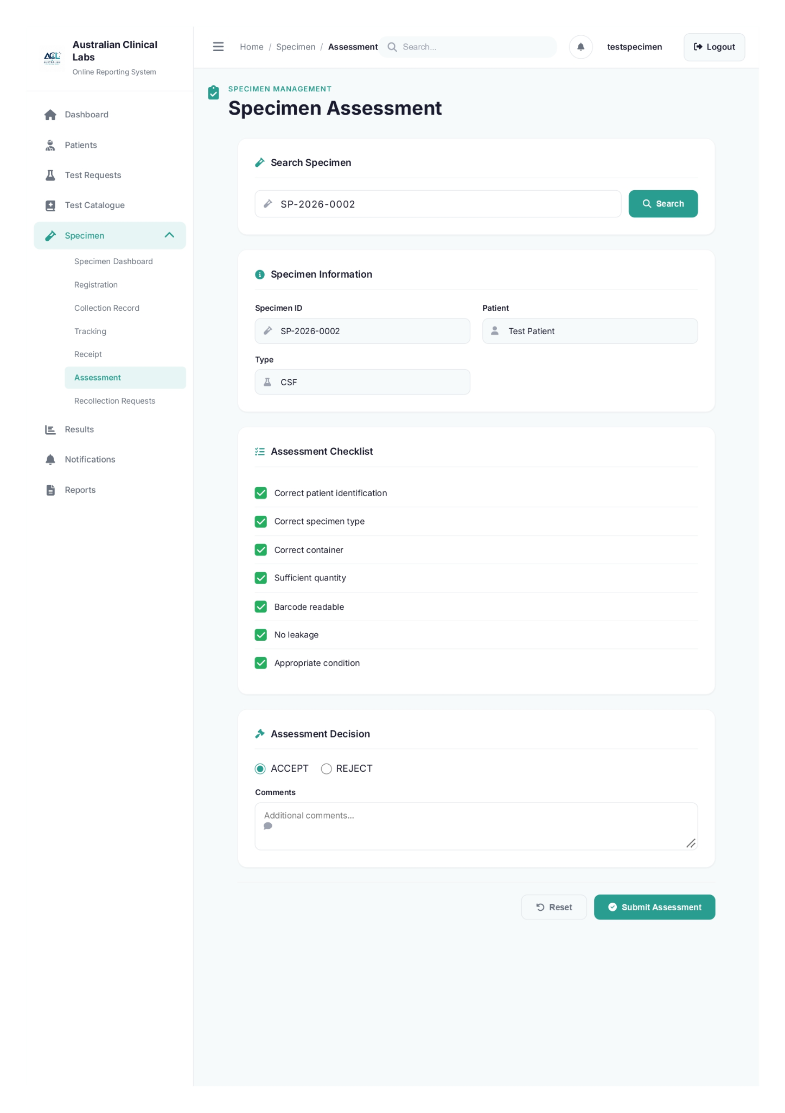

assessment.php
<?php
if (session_status() === PHP_SESSION_NONE) {
session_start();
}

require_once __DIR__ . '/functions.php';

if (
empty($_SESSION['authenticated']) ||
($_SESSION['portal'] ?? '') !== 'staff' ||
empty($_SESSION['mfa_verified']) ||
!in_array('specimen_collector', $_SESSION['roles'] ?? [], true)
) {
header('Location: ../auth/login.php?portal=staff');
exit;
}

$currentUser = getCurrentDisplayName();
?>
<!DOCTYPE html>
<html lang="en">
<head>
<meta charset="UTF-8">
<meta name="viewport" content="width=device-width, initial-scale=1.0">
<title>Specimen Assessment - Australian Clinical Labs</title>
<link rel="stylesheet" href="../../css/specimen/styles.css">
<link rel="stylesheet" href="../../css/specimen/forms.css">
<link href="https://fonts.googleapis.com/css2?family=Inter:wght@300;400;500;600;700&display=swap" rel="stylesheet">
<link rel="stylesheet" href="https://cdnjs.cloudflare.com/ajax/libs/font-awesome/6.4.0/css/all.min.css">
</head>
<body>
<div class="app-container">
<aside class="sidebar">
<div class="sidebar-header"><div class="logo"><img src="../../images/alc-logo.png" alt="ALC Logo"><div class="logo-text"><h1>Australian Clinical Labs</h1><span>Online Reporting System</span></div></div></div>
<nav class="sidebar-nav">
<ul class="nav-list">
<li class="nav-item"><a href="#" class="nav-link"><i class="fas fa-home"></i><span>Dashboard</span></a></li>
<li class="nav-item"><a href="#" class="nav-link"><i class="fas fa-user-injured"></i><span>Patients</span></a></li>
<li class="nav-item"><a href="#" class="nav-link"><i class="fas fa-flask"></i><span>Test Requests</span></a></li>
<li class="nav-item"><a href="#" class="nav-link"><i class="fas fa-book-medical"></i><span>Test Catalogue</span></a></li>
<li class="nav-item has-submenu active"><a href="#" class="nav-link submenu-toggle" onclick="toggleSubmenu(event)"><i class="fas fa-vial"></i><span>Specimen</span><i class="fas fa-chevron-down submenu-icon"></i></a>
<ul class="submenu show">
<li><a href="index.php" class="submenu-link">Specimen Dashboard</a></li>
<li><a href="registration.php" class="submenu-link">Registration</a></li>
<li><a href="collection.php" class="submenu-link">Collection Record</a></li>
<li><a href="tracking.php" class="submenu-link">Tracking</a></li>
<li><a href="receipt.php" class="submenu-link">Receipt</a></li>
<li><a href="assessment.php" class="submenu-link active">Assessment</a></li>
<li><a href="recollection.php" class="submenu-link">Recollection Requests</a></li>
</ul>
</li>
<li class="nav-item"><a href="#" class="nav-link"><i class="fas fa-chart-bar"></i><span>Results</span></a></li>
<li class="nav-item"><a href="#" class="nav-link"><i class="fas fa-bell"></i><span>Notifications</span></a></li>
<li class="nav-item"><a href="#" class="nav-link"><i class="fas fa-file-alt"></i><span>Reports</span></a></li>
</ul>
</nav>
</aside>
<main class="main-content">
<header class="top-header">
<div class="header-left"><button class="menu-toggle" onclick="toggleSidebar()"><i class="fas fa-bars"></i></button><nav class="breadcrumb"><a href="index.php">Home</a><span class="separator">/</span><a href="index.php">Specimen</a><span class="separator">/</span><span class="current">Assessment</span></nav></div>
<div class="header-right"><div class="search-bar"><i class="fas fa-search"></i><input type="text" placeholder="Search..."></div><div class="header-actions"><button class="icon-btn"><i class="fas fa-bell"></i></button><div class="user-profile"><span><?= htmlspecialchars($currentUser, ENT_QUOTES, 'UTF-8') ?></span></div><a href="../auth/logout.php" class="btn btn-secondary" style="padding:0.7rem 1rem; margin-left:0.75rem;"><i class="fas fa-sign-out-alt"></i> Logout</a></div></div>
</header>
<div class="dashboard-content">
<div class="page-header"><div class="page-title"><i class="fas fa-clipboard-check"></i><div><h2>SPECIMEN MANAGEMENT</h2><h1>Specimen Assessment</h1></div></div></div>
<div class="form-container">
<div class="form-section"><h3><i class="fas fa-vial"></i> Search Specimen</h3><div class="scan-input-group"><div class="input-group" style="flex:1;"><i class="fas fa-vial"></i><input type="text" id="assessSpecimenIdInput" placeholder="Enter specimen ID..." autofocus></div><button type="button" class="btn btn-primary" data-assessment-search><i class="fas fa-search"></i> Search</button></div></div>
<form id="assessmentForm" class="specimen-form">
<div id="assessSpecimenInfo" class="form-section" style="display:none;"><h3><i class="fas fa-info-circle"></i> Specimen Information</h3><div class="form-row"><div class="form-group"><label>Specimen ID</label><div class="input-group"><i class="fas fa-vial"></i><input type="text" id="assessSpecimenId" name="specimen_id" readonly></div></div><div class="form-group"><label>Patient</label><div class="input-group"><i class="fas fa-user"></i><input type="text" id="assessPatient" readonly></div></div></div><div class="form-row"><div class="form-group"><label>Type</label><div class="input-group"><i class="fas fa-flask"></i><input type="text" id="assessType" readonly></div></div></div></div>
<div class="form-section"><h3><i class="fas fa-tasks"></i> Assessment Checklist</h3><ul class="checklist"><li class="checklist-item"><div class="checklist-checkbox" tabindex="0" role="button" aria-label="Correct patient identification"></div><span class="checklist-label">Correct patient identification</span></li><li class="checklist-item"><div class="checklist-checkbox" tabindex="0" role="button" aria-label="Correct specimen type"></div><span class="checklist-label">Correct specimen type</span></li><li class="checklist-item"><div class="checklist-checkbox" tabindex="0" role="button" aria-label="Correct container"></div><span class="checklist-label">Correct container</span></li><li class="checklist-item"><div class="checklist-checkbox" tabindex="0" role="button" aria-label="Sufficient quantity"></div><span class="checklist-label">Sufficient quantity</span></li><li class="checklist-item"><div class="checklist-checkbox" tabindex="0" role="button" aria-label="Barcode readable"></div><span class="checklist-label">Barcode readable</span></li><li class="checklist-item"><div class="checklist-checkbox" tabindex="0" role="button" aria-label="No leakage"></div><span class="checklist-label">No leakage</span></li><li class="checklist-item"><div class="checklist-checkbox" tabindex="0" role="button" aria-label="Appropriate condition"></div><span class="checklist-label">Appropriate condition</span></li></ul></div>
<div class="form-section"><h3><i class="fas fa-gavel"></i> Assessment Decision</h3><div class="radio-group"><label class="radio-option"><input type="radio" name="assessment" value="accept" checked><span>ACCEPT</span></label><label class="radio-option"><input type="radio" name="assessment" value="reject"><span>REJECT</span></label></div><div id="rejectReasonDiv" class="form-group" style="display:none;margin-top:16px;"><label for="rejectReason">Reason for Rejection</label><div class="input-group"><i class="fas fa-exclamation-triangle"></i><select id="rejectReason" name="reject_reason"><option value="">Select reason</option><option value="Insufficient quantity">Insufficient quantity</option><option value="Wrong container">Wrong container</option><option value="Hemolyzed">Hemolyzed</option><option value="Clotted">Clotted</option><option value="Labeling error">Labeling error</option><option value="Other">Other</option></select></div></div><div class="form-group" style="margin-top:16px;"><label for="assessComments">Comments</label><div class="input-group"><i class="fas fa-comment"></i><textarea id="assessComments" name="comments" rows="3" placeholder="Additional comments..."></textarea></div></div></div>
<div class="form-actions"><button type="reset" class="btn btn-outline"><i class="fas fa-undo"></i> Reset</button><button type="submit" class="btn btn-primary"><i class="fas fa-check-circle"></i> Submit Assessment</button></div>
</form>
</div>
</div>
</main>
</div>
<script src="../../js/specimen/script.js?v=<?= time() ?>"></script>
</body>
</html>

- Recollection Request

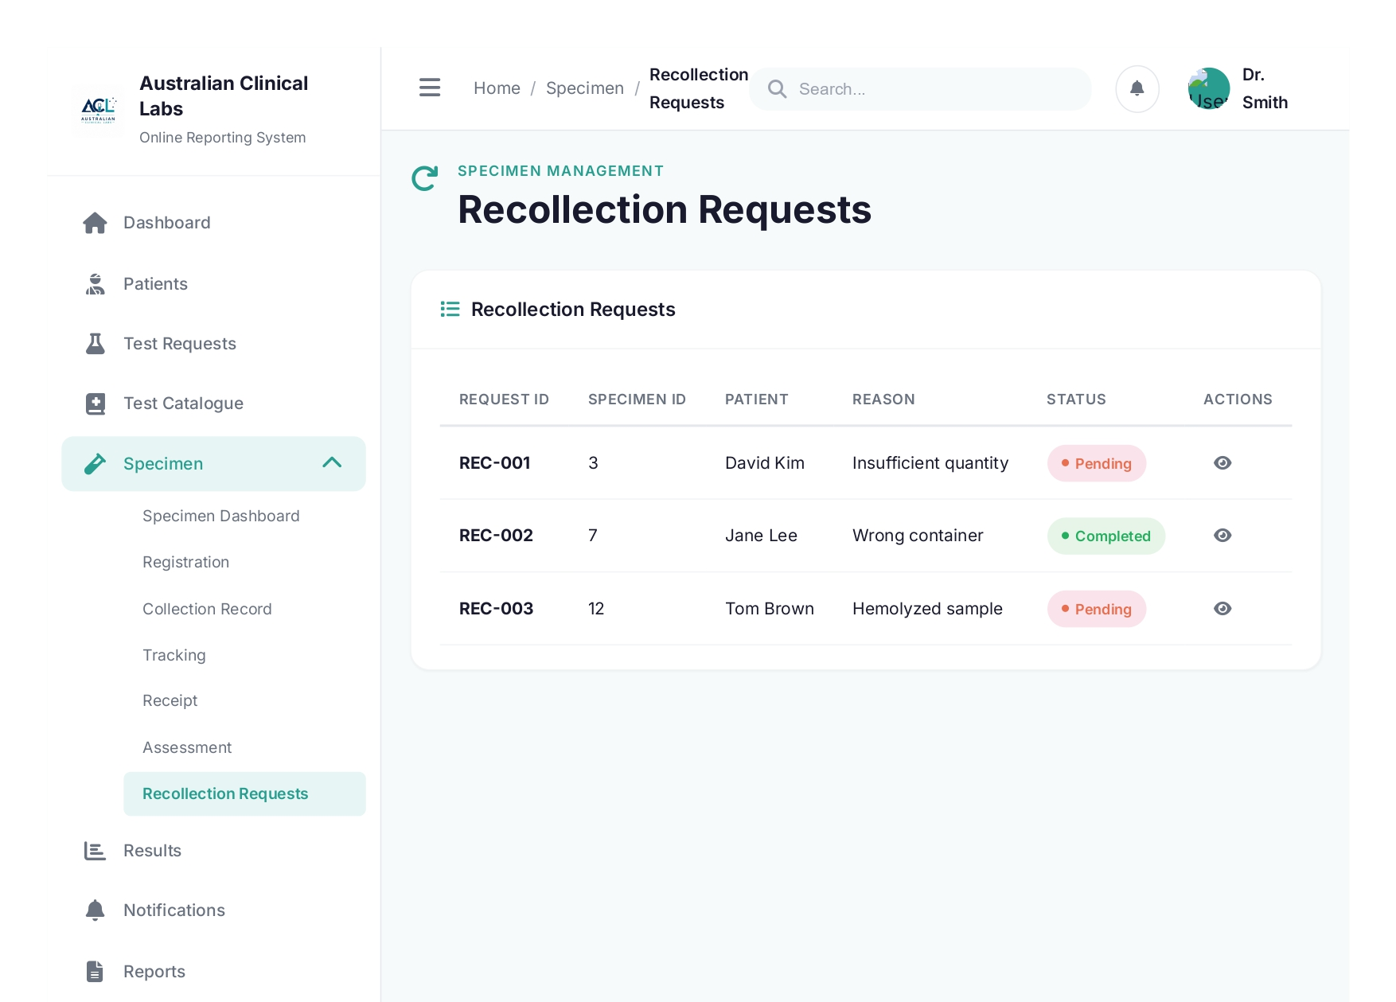

recollection.php
<?php
session_start();
require_once __DIR__ . '/functions.php';

$currentUser = getCurrentDisplayName();
$recollections = [];
$statusColors = ['Pending' => 'status-pending', 'Completed' => 'status-accepted', 'In Progress' => 'status-transit'];

try {
$pdo = db();
$stmt = $pdo->query(
"SELECT rr.recollection_id AS id, rr.original_specimen_id AS specimen_id, TRIM(CONCAT(COALESCE(p.first_name, ''), ' ', COALESCE(p.last_name, ''))) AS patient, rr.request_id, rr.reason, rr.requested_by, rr.status
FROM recollection_requests rr
LEFT JOIN patients p ON p.patient_id = rr.patient_id
ORDER BY rr.created_at DESC"
);
$recollections = $stmt->fetchAll(PDO::FETCH_ASSOC);
} catch (Throwable $e) {
error_log('Failed to load recollection requests: ' . $e->getMessage());
}
?>
<!DOCTYPE html>
<html lang="en">
<head>
<meta charset="UTF-8">
<meta name="viewport" content="width=device-width, initial-scale=1.0">
<title>Recollection Requests - Australian Clinical Labs</title>
<link rel="stylesheet" href="../../css/specimen/styles.css">
<link rel="stylesheet" href="../../css/specimen/forms.css">
<link href="https://fonts.googleapis.com/css2?family=Inter:wght@300;400;500;600;700&display=swap" rel="stylesheet">
<link rel="stylesheet" href="https://cdnjs.cloudflare.com/ajax/libs/font-awesome/6.4.0/css/all.min.css">
</head>
<body>
<div class="app-container">
<aside class="sidebar">
<div class="sidebar-header"><div class="logo"><img src="../../images/alc-logo.png" alt="ALC Logo"><div class="logo-text"><h1>Australian Clinical Labs</h1><span>Online Reporting System</span></div></div></div>
<nav class="sidebar-nav">
<ul class="nav-list">
<li class="nav-item"><a href="#" class="nav-link"><i class="fas fa-home"></i><span>Dashboard</span></a></li>
<li class="nav-item"><a href="#" class="nav-link"><i class="fas fa-user-injured"></i><span>Patients</span></a></li>
<li class="nav-item"><a href="#" class="nav-link"><i class="fas fa-flask"></i><span>Test Requests</span></a></li>
<li class="nav-item"><a href="#" class="nav-link"><i class="fas fa-book-medical"></i><span>Test Catalogue</span></a></li>
<li class="nav-item has-submenu active"><a href="#" class="nav-link submenu-toggle" onclick="toggleSubmenu(event)"><i class="fas fa-vial"></i><span>Specimen</span><i class="fas fa-chevron-down submenu-icon"></i></a>
<ul class="submenu show">
<li><a href="index.php" class="submenu-link">Specimen Dashboard</a></li>
<li><a href="registration.php" class="submenu-link">Registration</a></li>
<li><a href="collection.php" class="submenu-link">Collection Record</a></li>
<li><a href="tracking.php" class="submenu-link">Tracking</a></li>
<li><a href="receipt.php" class="submenu-link">Receipt</a></li>
<li><a href="assessment.php" class="submenu-link">Assessment</a></li>
<li><a href="recollection.php" class="submenu-link active">Recollection Requests</a></li>
</ul>
</li>
<li class="nav-item"><a href="#" class="nav-link"><i class="fas fa-chart-bar"></i><span>Results</span></a></li>
<li class="nav-item"><a href="#" class="nav-link"><i class="fas fa-bell"></i><span>Notifications</span></a></li>
<li class="nav-item"><a href="#" class="nav-link"><i class="fas fa-file-alt"></i><span>Reports</span></a></li>
</ul>
</nav>
</aside>
<main class="main-content">
<header class="top-header">
<div class="header-left"><button class="menu-toggle" onclick="toggleSidebar()"><i class="fas fa-bars"></i></button><nav class="breadcrumb"><a href="index.php">Home</a><span class="separator">/</span><a href="index.php">Specimen</a><span class="separator">/</span><span class="current">Recollection Requests</span></nav></div>
<div class="header-right"><div class="search-bar"><i class="fas fa-search"></i><input type="text" placeholder="Search..."></div><div class="header-actions"><button class="icon-btn"><i class="fas fa-bell"></i></button><div class="user-profile"><span><?= htmlspecialchars($currentUser, ENT_QUOTES, 'UTF-8') ?></span></div><a href="../auth/logout.php" class="btn btn-secondary" style="padding:0.7rem 1rem; margin-left:0.75rem;"><i class="fas fa-sign-out-alt"></i> Logout</a></div></div>
</header>
<div class="dashboard-content">
<div class="page-header"><div class="page-title"><i class="fas fa-redo"></i><div><h2>SPECIMEN MANAGEMENT</h2><h1>Recollection Requests</h1></div></div></div>
<div class="dashboard-card">
<div class="card-header"><h3><i class="fas fa-list"></i> Recollection Requests</h3></div>
<div class="card-body"><table class="data-table"><thead><tr><th>Request ID</th><th>Specimen ID</th><th>Patient</th><th>Reason</th><th>Status</th><th>Actions</th></tr></thead><tbody>
<?php foreach ($recollections as $rec): ?>
<tr><td><strong><?php echo $rec['id']; ?></strong></td><td><?php echo $rec['specimen_id']; ?></td><td><?php echo $rec['patient']; ?></td><td class="reason-cell"><span class="truncate"><?php echo $rec['reason']; ?></span></td><td><span class="status-badge <?php echo $statusColors[$rec['status']]; ?>"><?php echo $rec['status']; ?></span></td><td><button class="btn-icon" title="View" onclick="viewRecollectionDetails('<?php echo $rec['id']; ?>')"><i class="fas fa-eye"></i></button></td></tr>
<?php endforeach; ?>
</tbody></table></div>
</div>
</div>
</main>
</div>
<div id="recollectionModal" class="modal-overlay">
<div class="modal">
<div class="modal-header"><h3>Recollection Request Details</h3><button class="modal-close" onclick="closeModal('recollectionModal')"><i class="fas fa-times"></i></button></div>
<div class="modal-body"><div class="form-row"><div class="form-group"><label>Recollection ID</label><div class="input-group"><input type="text" id="modalRecId" readonly></div></div><div class="form-group"><label>Original Specimen</label><div class="input-group"><input type="text" id="modalSpecimenId" readonly></div></div></div><div class="form-row"><div class="form-group"><label>Patient</label><div class="input-group"><input type="text" id="modalPatient" readonly></div></div><div class="form-group"><label>Test Request</label><div class="input-group"><input type="text" id="modalTestRequest" readonly></div></div></div><div class="form-row"><div class="form-group"><label>Reason</label><div class="input-group"><textarea id="modalReason" rows="2" readonly></textarea></div></div></div><div class="form-row"><div class="form-group"><label>Requested By</label><div class="input-group"><input type="text" id="modalRequestedBy" readonly></div></div><div class="form-group"><label>Status</label><div class="input-group"><input type="text" id="modalStatus" readonly></div></div></div></div>
<div class="modal-footer"><button class="btn btn-outline" onclick="closeModal('recollectionModal')">Close</button><a href="registration.php" class="btn btn-primary"><i class="fas fa-plus"></i> Register Recollected Specimen</a></div>
</div>
</div>
<script src="../../js/specimen/forms.js"></script>
<script src="../../js/specimen/script.js"></script>
<script>
const recollectionLookup = <?php echo json_encode(array_column($recollections, null, 'id')); ?>;
function viewRecollectionDetails(id) {
const r = recollectionLookup[id];
if (!r) {
return;
}
document.getElementById('modalRecId').value = id;
document.getElementById('modalSpecimenId').value = r.specimen_id;
document.getElementById('modalPatient').value = r.patient || 'Not available';
document.getElementById('modalTestRequest').value = r.request_id || 'Not available';
document.getElementById('modalReason').value = r.reason || '';
document.getElementById('modalRequestedBy').value = r.requested_by || 'Not available';
document.getElementById('modalStatus').value = r.status || 'Pending';
showModal('recollectionModal');
}
</script>
</body>
</html>

